**MODULE 2: CRIME COUNT PER YEAR**

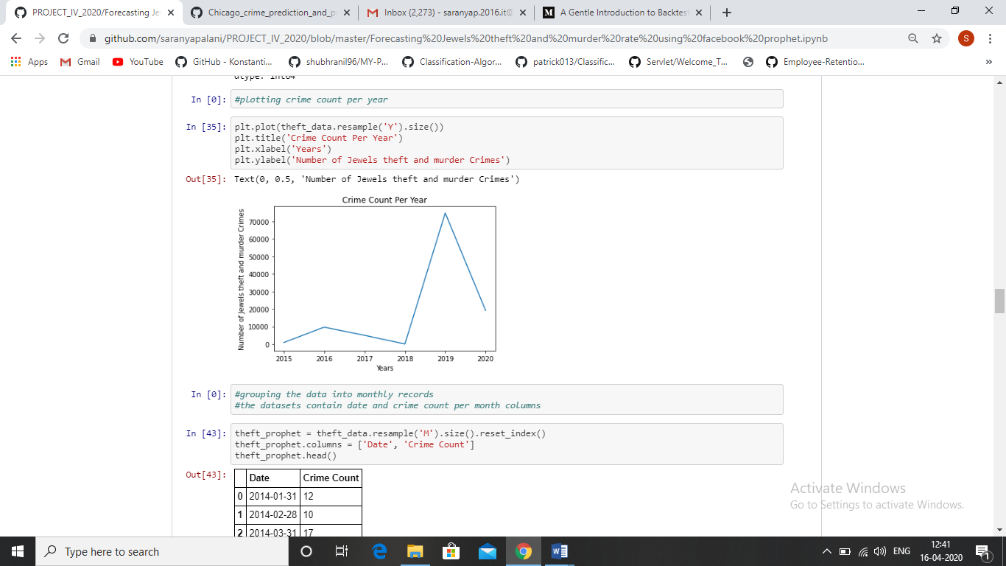

Figure 3